**CURRICULUM VITAE**

Name : Mobile No : Mail ID : Date of Birth : Nationality :

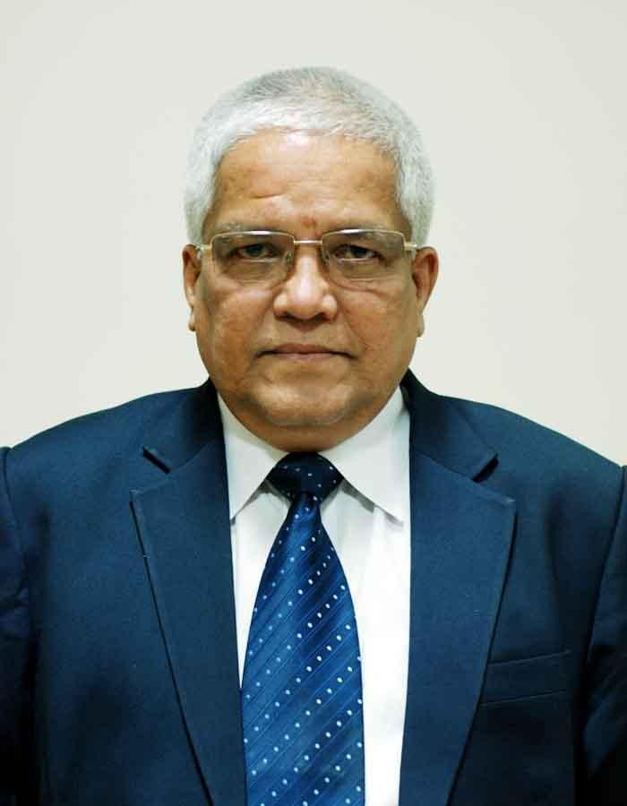

Educational

Qualifications :

Working Experience :

**M.G.GOPAL, IAS (Rtd)**

09849020575 [mggopal57@gmail.com](mailto:mggopal57@gmail.com)

2nd February, 1957

Indian

Post Graduate in Commerce

CAIIB (Certificated Associate of Indian Institute of Bankers) PGDPEM (PG Diploma in Public Enterprises Management) Diploma in Equipment Procurement Management ( trained at

ILO, Italy)

Joined Union Bank of India as a Probationary Officer and worked between January 1977 and August 1983. Worked in the Development Manager’s Office and Regional Office looking after credit processing work.

Joined the Indian Administrative Service in September 1983 and superannuated in February 2017.

Among the important assignment held in the IAS are:

- **Spl. Chief Secretary, Revenue Dept.,** Government of

Telangana. ( Dec 2016 - Feb 2017)

- Worked as **Spl. Chief Secretary, MA & UD Dept.,** Government of Telangana. Responsible for introducing reforms to facilitate growth in real estate sector. Also introduced Online Buildings and layout approval system in Urban local bodies (DPMS) which is one of the factors contributing to State of Telangana securing top rank in Ease of Doing Business. (Jan 2015 – Dec 2016)

- Worked as **Executive Officer, Tirumala Tirupati Devasthanam**. Introduced the currently popular 3 level ‘Q’ System in Tirumala Temple and online advance reservation

system for getting Darshan in just 2 hours time.(July 2013 - January 2015)

- **Prl. Secretary to Government** of Andhra Pradesh in **Revenue (Endowments) Department**, Secretariat, Hyderabad, incharge of Commercial Taxes, Prohibition and Excise. Also held charge of the post of Vice Chancellor of Sri Venkateswara Vedic University, Tirupati. (Jan - July 2013)

- **Principal Secretary** to Government of Andhra Pradesh looking after **Higher & Technical Education**, Secretariat, Hyderabad. Streamlined the admission procedures against Management quota of Private Engineering Colleges and rationalized fee structure. (June 2011 - January 2013)

- **Secretary / Principal Secretary, A.P. Public Service**

**Commission**, Hyderabad Since June 2009 to June 2011.

- **Secretary / Prl. Secretary to H.E. the Governor** of

Andhra Pradesh, Raj Bhavan, Hyderabad since November

2005 to 2009. In this capacity took active interest in establishment of Sri Venkateswara Vedic University at Tirupati.

- **Secretary, A.P. Social Welfare Residential**

**Educational Institutions Society**, Hyderabad October,

2004 to October, 2005.

- **Secretary, Rain Shadow Areas Development**

**Department** from June, 2004 to October, 2004.

- **Managing Director, Hyderabad Metropolitan Water**

**Supply & Sewerage Board** (September, 2000 to May

2004). Improved the finances of the organization and made it creditworthy. Conceived, designed, implemented and commissioned first phase of Krishna Drinking Water supply project to twin cities.

- **Commissioner, Environment Protection Training & Research Institute,** Hyderabad (1998-2000) – Turned around the organization making it stand on its own, technically, commercially and financially with the handholding assistance given by Swedish International Development Cooperation Agency (SIDA).

- **Director of Tourism and Managing Director,** A.P. Travel and Tourism Development Corporation (1997-98) –

got the master plans for tourism development in special tourism areas of the State with the help of expatriate (EDAW, UK) consultants which were sustainable and implemented later.

- **Joint Secretary, Project Management Unit, Finance and Planning Dept.** Government of AP (1992-1994) – Managed World Bank group assisted AP Cyclone Emergency Reconstruction Project (US $ 385 Millions ) and ensured timely completion of project. The project completion Report appreciated the manner of implementation of this project.

- **Collector and Dist. Magistrate, Adilabad Dist.** (1990-1992) Visakhapatnam District (1995-1997) – Revenue, magisterial and development head of the district guiding the overall development of the districts. Organised the currently population ‘Vishakha Utsav’ for the first time in 1995-96.

- **Project Officer, Integrated Tribal Development**

**Agency, Ethurunagaram,** Warangal District (1987 – 1990)

– with headquarters in a tribal village in forest area, worked for the food and economic security of the tribals in the sub plan area. Also got the lands under cultivation of tribals prior to 1980 (Forest Conservation Act) surveyed to protect their occupation.

Other Interests :

- **Sub-Collector, and Sub-Divisional Magistrate, Asifabad (1985-1987) and Kothagudem (1987)** – as Revenue Magisterial and Development head of the sub-division resolved many land related issues of the economically weaker sections.

- As guest faculty, gave presentations and lectured on Change Management and World Bank procurement Procedures in Administrative Staff College of India before several groups.

- Finalized the City Development Strategy for Hyderabad

Metropolitan Area for the Watsan sector.

- Was an active Member of the Changed Management Forum, constituted by M/o Urban Development and Poverty Alleviation, GOI and ASCI.